**Week 12**

This week I was looking at if the correlation function could provide some new insight into the dynamics after a quench. This was inspired by the use of the correlation function to describe the Quantum Kibble Zurek Mechanism (QKZM) as done in this paper from the Lukin group: <https://www.nature.com/articles/s41586-019-1070-1>

The Quantum Kibble Zurek mechanism describes the formation of topological defects in an order system when it is driven through a phase transition to quickly to be fully adiabatic. It an important concept in quantum annealing where defects in the system are associate with errors. As a result, finding optimal annealing regime such that defects are minimise is an active area of research.

Since Rydberg atom arrays have a lot of potential to act as the hardware for solving a lot of annealing problems understanding how these defects arise and if/how they propagate is interesting give the scope of our system.

The correlation function tells us conditional probabilities between atom states. For example is we find atom 1 in the ground state how likely is atom 2 to be in the ground state.

The correlation function is defined:

We can also write the generalised correlation function for two sites separated by a distance r by summing over all pairs separated by that distance

The correlation is another tool which we can use to evaluate the vast parameter space of the quench. Not only does it show that after a quench atoms become increasingly correlated but also indicate how corelations are distributed amongst the atoms. In the plots below it is apparent that larger quenches (quenches from higher detuning) result in stronger longer range corelations. In the following week, I will have a look at ways to quantify this effect as well as better explaining what the correlation function measures (starting from a two atom system.

**5 Atom G(1,i)**

= 20 MHz

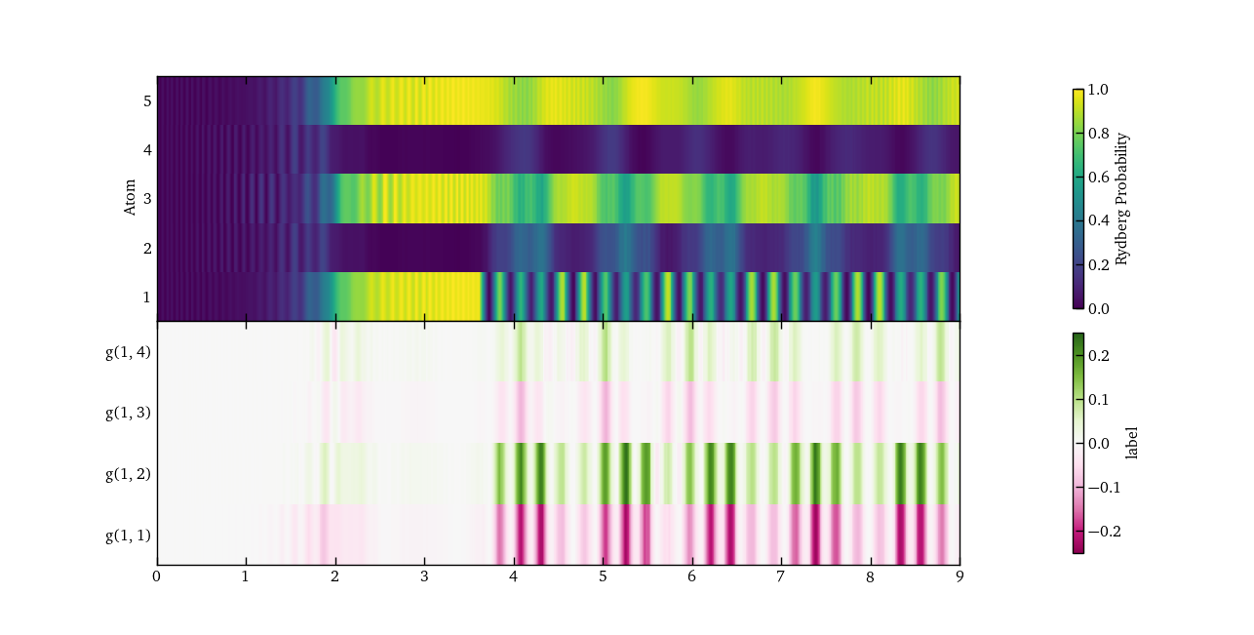

= 25 MHz

= 30 MHz

= V12 = 31.8 MHz

